Broadcast Message in Pega

Pega allows us to create short bulletins like Welcome Messages or news or message of the day by using Broadcast data instance.

It is created as an instance of Data-Broadcast class.

Keys for this class are

* pyOrganization
* pyOrgDivision
* pyOrgUnit

there can be one broadcast data instance per organization division’s unit.

Messages of upto 70 characters of length can be entered

We can display a broadcast message by using OOTB section @basclass.News can be referenced wherever we need to display the Broadcast message we have created.

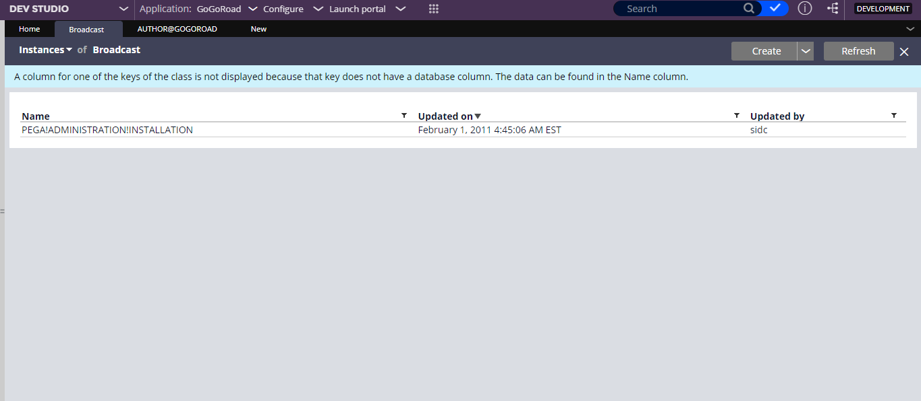

Now this will be shown in the portal

Now for this

Local Action @baseclass.EditNews is used to edit the message rule.

Pre-Activity @baseclass.NewBroadcastMessge fetches the broadcast message associated with the current logged in operator’s Org-Div-Unit. Post activity @baseclass.EditNews, updates the corresponding Broadcast rule with edited message.

So now the comparison to the Broadcast with Field Value

For displaying messages, we can make use of Field Value. There are no restrictions on the number of characters to display in case of field value messages. Editing message needs access to Developer portal as field value rule has ruleset version associated to it. Whereas broadcast option, message can be easily edited without the need of Developer Portal as it does not have any ruleset.

Conclusion

We can make use of Broadcast rule to present updates to user’s belonging to a particular Unit and also allow authorized users to edit the messages as needed without needing to login into Developer portal to make the changes.